Quick Guide

ADJUSTABLE HORIZONTAL BARS

SALES AND SERVICE
joombeem.com

PS Newby LLC
1430 Enterprise Ave
Myrtle Beach, SC 29577
sales@joombeem.com
service@joombeem.com

The perfect starter equipment for budding gymnasts, the Joom Beem Adjustable Horizontal Bar is also great as activity equipment for toddlers to pre-teens.
Read the quick assembly guide and instructions through before attempting to assemble and use your Adjustable Horizontal Bar.

Warning!
• Assembly and adjustment of this product should be undertaken by a qualified adult
• The Joom Beem Adjustable Horizontal Bar is rated for persons weighing 140 lb or less
• Suitable for gymnast levels 1 to 4

Tools
• Two wrenches
• Power drill
• Phillips head screwdriver

Parts list
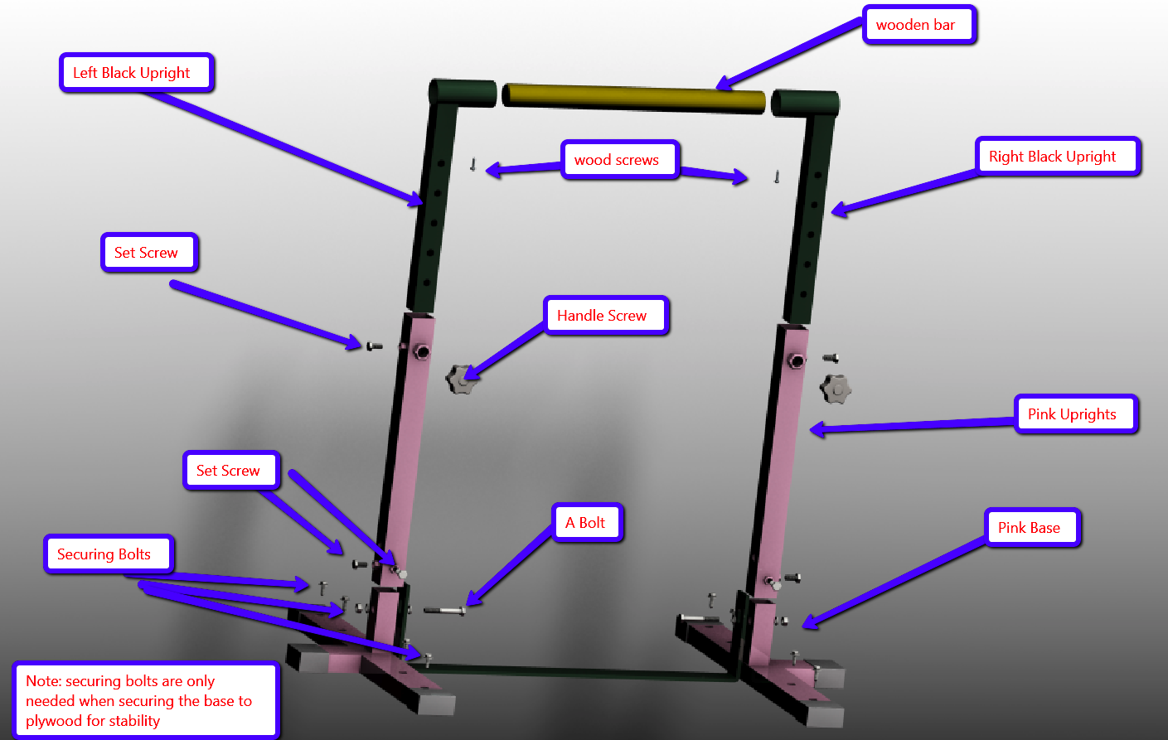
1. Wooden bar
2. Wood screws
3. Left Black Upright bar
4. Right Black Upright bar
5. Set screws
6. Handle screws
7. Pink Upright bars
8. A bolts
9. Pink Base bars
10. Black base bar (Loids, please put a number on the lowest bar joining the two pink base bars, it isn’t identified in the drawing)
11. Securing bolts
Note: Securing bolts are only needed when securing the base to plywood for stability.

Assembly
1. Unpack the parts of the Adjustable Horizontal Bar.

2. Line up the Pink Base holes with the holes of the black base bar.

3. Insert the Left and Right Black Upright bars into the corresponding Pink Upright bars. They should slide right in.

4. Attach the Pink Upright bars to the black base bar using the provided A bolts, nuts, and washers. Secure the Pink Upright bars to the Pink Base bars with the provided set screws as well.

5. Make sure the A bolts are tight using two wrenches.

6. Insert the Wooden bar into the Left and Right Black Upright bars. Secure with provided wood screws.

7. Insert the Handle Screws into the holes provided in the Left and Right Black Upright bars. Align it to the appropriate hole on the barz. You can adjust the height to 36, 42, 48, 54, and 60 inches.

Tip: Check the stability by applying some weight to the bars. It should not feel loose or wobble excessively. At this point, you can choose to use the securing bolts to attach the base to a wooden platform for added stability. Bolts for attaching to plywood are included in this kit.

8. Lay down your gymnast mat.

Your Joom Beem Adjustable Horizontal Bar is now ready for use!

Tip: You may attach and secure extension bars to the base bar for added stability. (If you purchased the Stabilization Kit - sold separately)

Note: Horizontal bars will move when doing kips and similar skills. This is normal for all home use horizontal bars. This does not mean the bars will tip over. This product has been rigorously tested with 200-lb adults doing kips and similar skills to make sure it can not tip over or break.

If you want to maximally secure your bars to minimize wobble, please get our horizontal bar stabilization kit which includes base extensions, bolts for attaching to plywood and bolts for attaching to concrete.

Safety precautions
The Joom Beem Adjustable Horizontal Bar involves activities that may cause serious injury to the user. Reduce your risk of injury by taking note of the following:
• The product is for persons not more than 140 lb in weight
• Do not leave your children unattended when using this product
• You MUST have proper matting in accordance with state law when using this product
• Check that the equipment is properly installed and adjusted. Look for loose parts and excessive wobbling. Replace worn or defective parts. Do not use if there are worn, missing or defective parts.

Warranty
The Joom Beem Adjustable Horizontal Bar is warranted against original defects in material and workmanship for a period of one (1) year from the date of purchase, when used for purposes in accordance with this Quick Guide. This warranty provides for the repair or replacement of the unit. Replacement product or parts may include re-manufactured or refurbished parts or components. Service under warranty will not extend this warranty period.

